**Upper Bounds Intelligent Tutoring System**

Version 5.0

**Project Team:**

Abhilash Alexander – Designer, Coder, Tester

Hector Duenas - Designer, Coder, Tester

Jesus Gomez – Designer, Coder, Tester

Vijay Ramakrishna – Leader, Analyst, Coder, Documentation

**Document Authors:**

Abhilash Alexander, Hector Duenas, Jesus Gomez, Vijay Ramakrishna,

**Customer Representative(s):**

Dr. Javier Gonzalez-Sanchez

1. **Introduction**

The goal of this project is to create an Intelligent Tutoring System that will help tutor students in Calculus I. This system will allow students to grasp and better understand the concepts of Calculus I. Teachers will be able to upload material from the course work and also add extra material that was not covered in class. The Intelligent Tutoring System will quiz students on the material and suggest where the student should focus more of his/her time on. It will allow the teacher to see how their students are doing and what to go over in class more.

**II. Class Diagram**

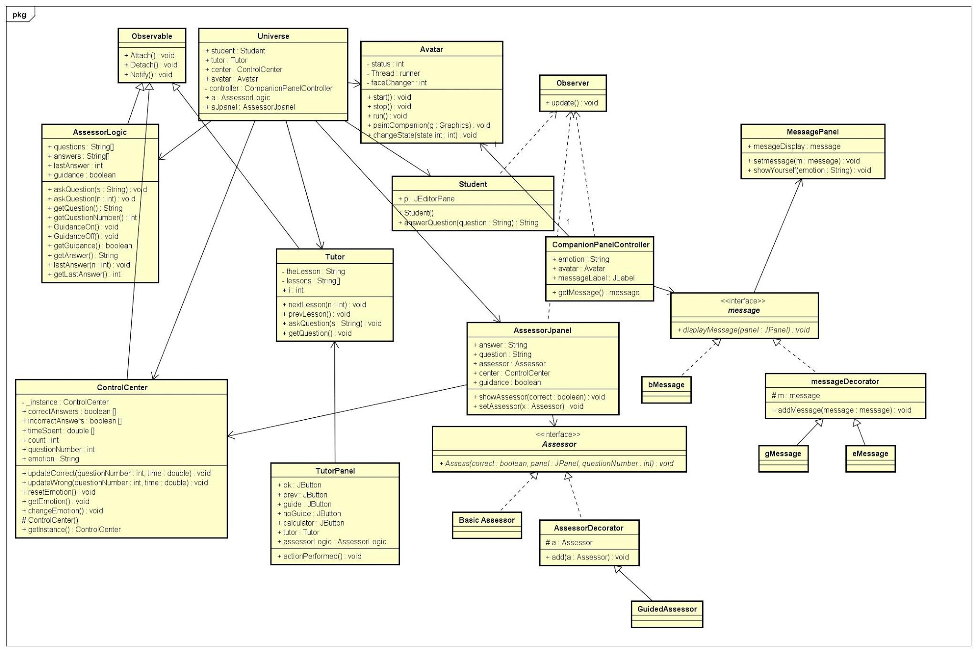

**III. Use Case Diagram**

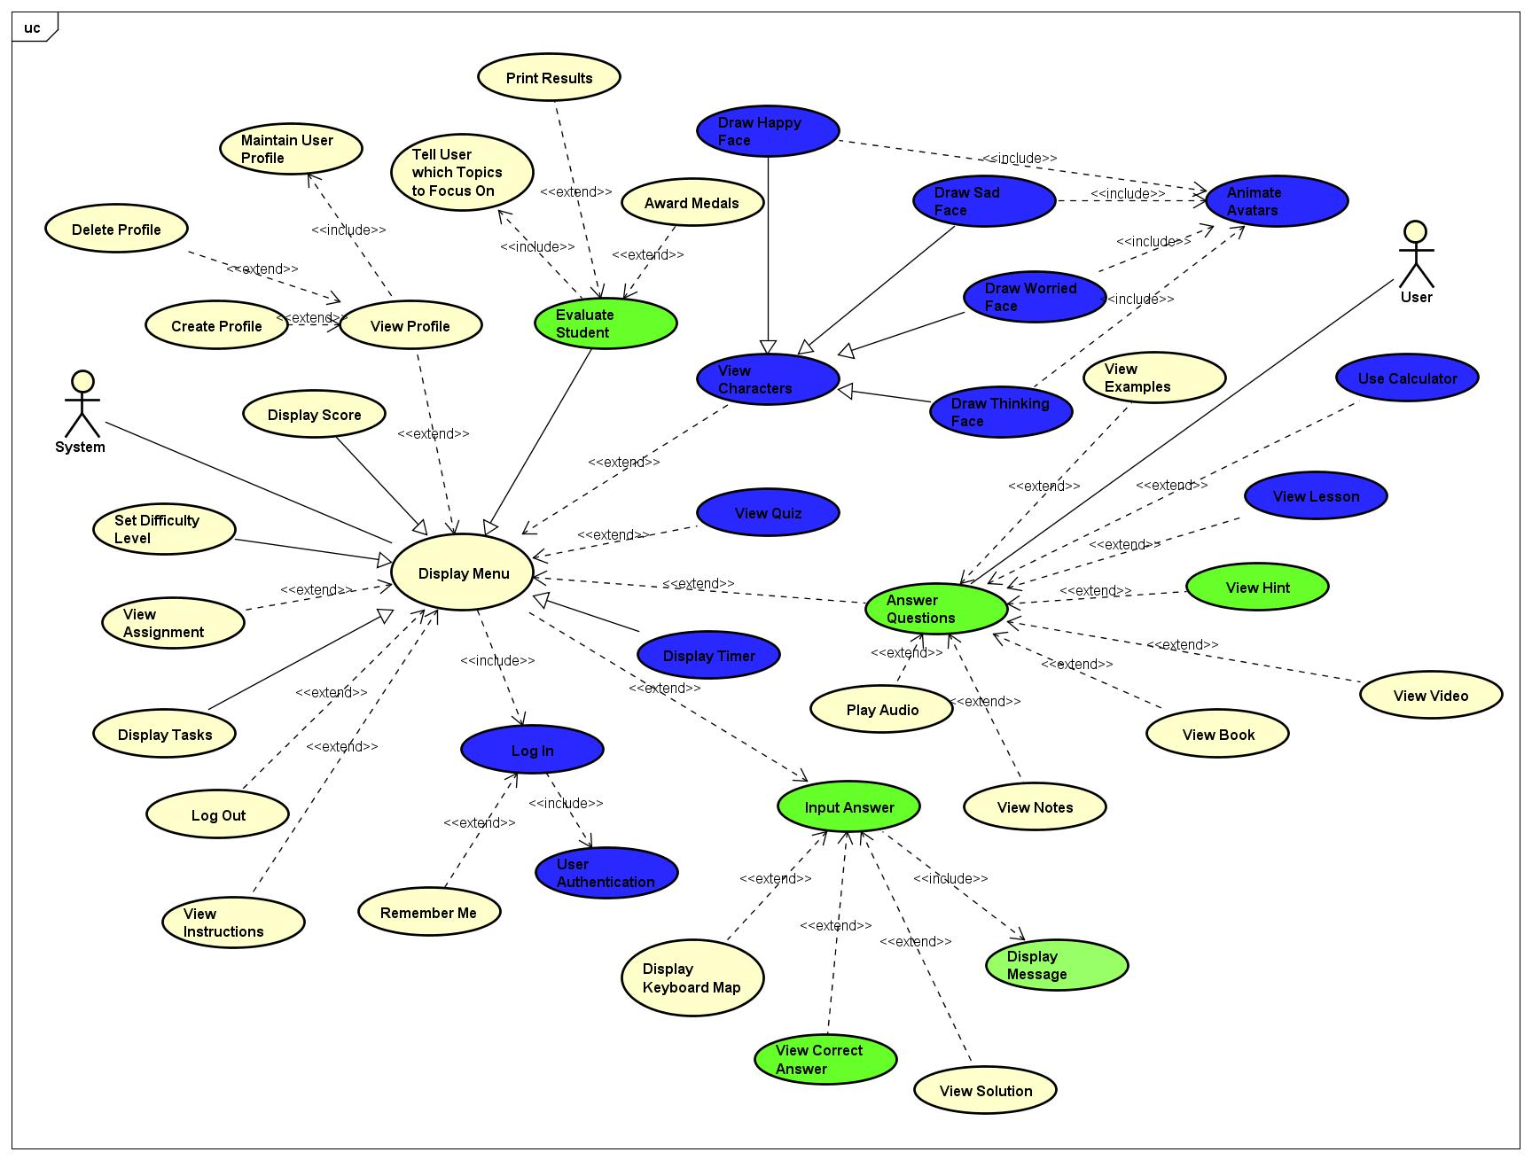

**IV. Use Case List**

|  |  |
| --- | --- |
| **UC1** | Display Happy Face |
| **UC2** | Display Worry Face |
| **UC3** | Display Sorry Face |
| **UC4** | Display Thinking Face |
| **UC5** | View Character |
| **UC6** | View Examples |
| **UC7** | View Book |
| **UC8** | Answer Questions |
| **UC9** | Display Message |
| **UC10** | View Hint |
| **UC11** | View Correct Answer |
| **UC12** | Display Timer |
| **UC13** | View Solution |
| **UC14** | Display Score |
| **UC15** | View Lesson |
| **UC16** | View Video |
| **UC17** | Play Audio |
| **UC18** | Input Answer |
| **UC19** | Animate Avatars |
| **UC20** | Delete Profile |
| **UC21** | Display Tasks |
| **UC22** | Maintain Student Information |
| **UC23** | View Profile |
| **UC24** | Create Profile |
| **UC25** | Log in |
| **UC26** | User Authentication |
| **UC27** | Use Calculator |
| **UC28** | Remember Me |
| **UC29** | Display Menu |
| **UC30** | View Instructions |
| **UC31** | View Notes |
| **UC32** | Set Difficulty Level |
| **UC33** | Tell User which Topics to Focus On |
| **UC34** | Award Medals |
| **UC35** | Display Keyboard Map |
| **UC36** | View Quiz |
| **UC37** | Print Results |
| **UC38** | View Assignment |
| **UC39** | Log Out |
| **UC40** | Evaluate Student |

**V. Flow of Events**

**UC1 Flow of Events for the Draw Happy Face Use Case**

1. **Brief Description**
   1. The goal of this requirement is to draw a face that looks happy. It will automatically be the first thing that the user will see when logging into the profile and begin their study session. This face will encourage students to keep trying and motivate them with their studies.

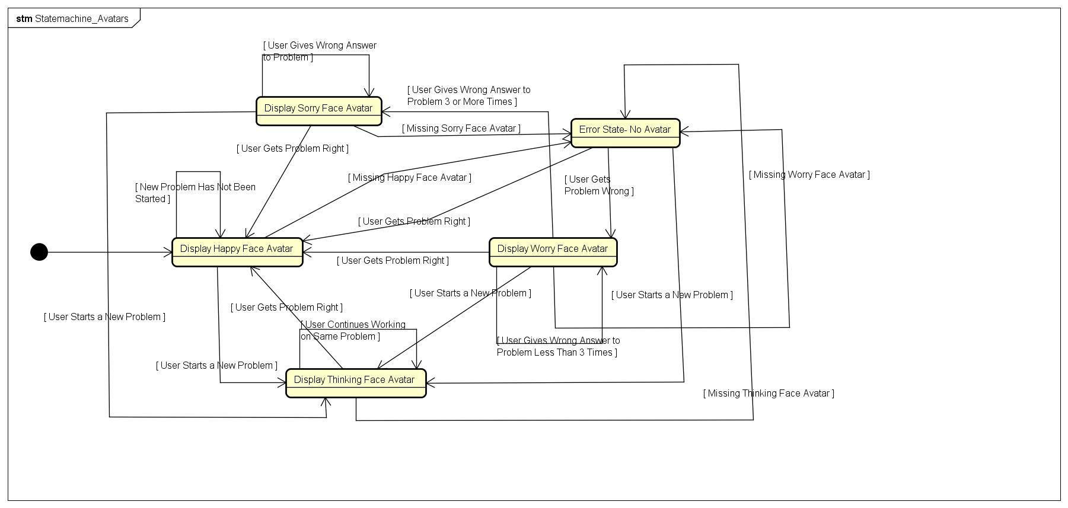

1. **Pre-Conditions**
   1. User Log In
2. **Post-Conditions**
   1. Happy Face is displayed on the screen.
3. **Failed End Condition**
   1. None
4. **Actors**
   1. User is able to view the character.

**UC2 Flow of Events for the Draw Thinking Face Use Case**

1. **Brief Description**
   1. The goal of this requirement is to draw a face that looks like if it is thinking. It will be displayed when the user is working on a problem. It will encourage the student to think about the problem and what the question is asking. Also when the their is a concept of the subject being displayed.



1. **Pre-Conditions**
   1. Logged in,User working on a problem or is reading a key concept.
2. **Post-Conditions**
   1. Thinking Face is displayed on the screen.
3. **Failed End Condition**
   1. None.
4. **Actors**
   1. User is able to view the character.

**UC3 Flow of Events for the Draw Worry Face Use Case**

1. **Brief Description**
   1. The goal of this requirement is to draw a face that looks like if it is worried for the student. It will be displayed when the user is gets a practice problem wrong. It will let the student know that, that is an area of study he should be focusing on.



1. **Pre-Conditions**
   1. Logged in, User gets a practice problem wrong.
2. **Post-Conditions**
   1. Worry Face is displayed on the screen.
3. **Failed End Condition**
   1. None.
4. **Actors**
   1. User is able to view the character.

**UC4 Flow of Events for the Draw Sorry Face Use Case**

1. **Brief Description**
   1. The goal of this requirement is to draw a face that looks like if it is sorry for the student. It will be displayed when the user is gets a quiz problem wrong or exam problem wrong. Also if the student keeps making the same practice problem wrong after the first time.



1. **Pre-Conditions**
   1. Logged in, User gets a bad grade.
2. **Post-Conditions**
   1. Sorry Face is displayed on the screen.
3. **Failed End Condition**
   1. None.
4. **Actors**
   1. User is able to view the character.

**UC5 Flow of Events for the View Characters Use Case**

1. **Brief Description**
   1. The goal of this requirement is that the user is able to view the character. The character is either a happy, thinking, worry, or sorry face. When he/she open the page the character will be visible to the User.



1. **Pre-Conditions**
   1. Logged in.
2. **Post-Conditions**
   1. User is able to view the character.
3. **Failed End Condition**
   1. None.
4. **Actors**
   1. User.

**UC6 Flow of Events for the View Examples Use Case**

1. **Brief Description**
   1. The goal of this requirement is to display an example of the question. It will be displayed when the user wants to see a similar type of question. User should be working on a similar type of question that time.

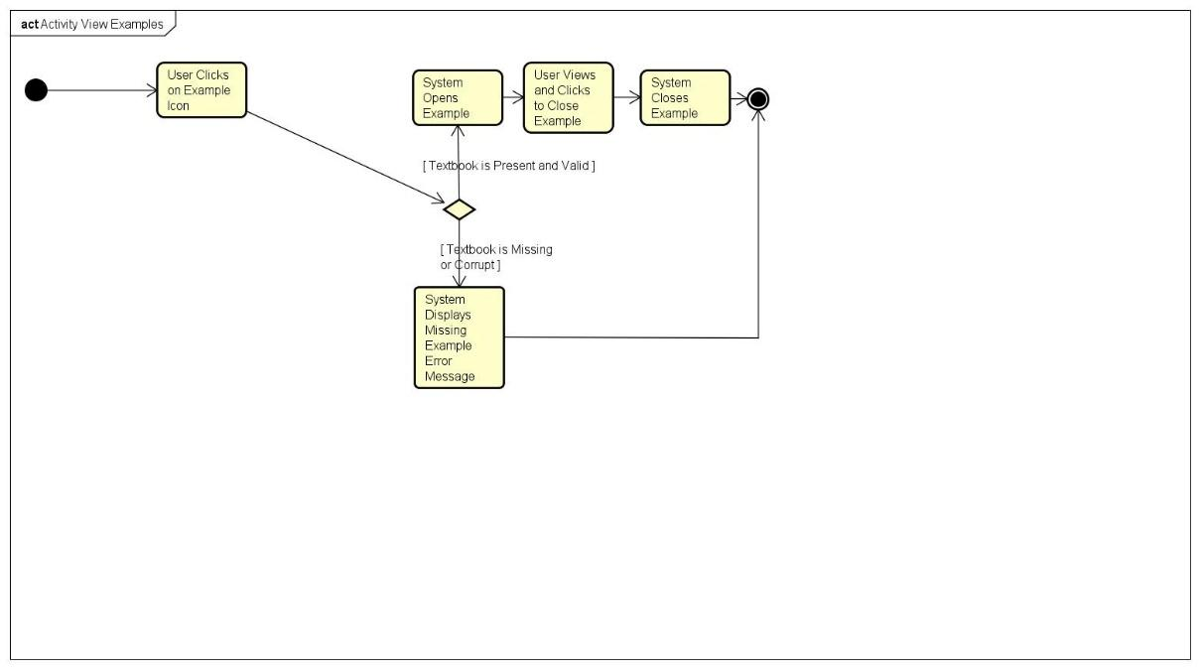

1. **Pre-Conditions**
   1. User must be logged onto the system and should be working on the question.
2. **Post-Conditions**
   1. Example of the question is displayed.
3. **Failed End Condition**

**i.** Example doesn’t show up

1. **Actors**
   1. User is able to view the Example.

**UC7 Flow of Events for the View Book Use Case**

1. **Brief Description**
   1. The goal of this requirement is to display the calculus book. It will be displayed when the User goes to resources and then clicks a tool named Book.

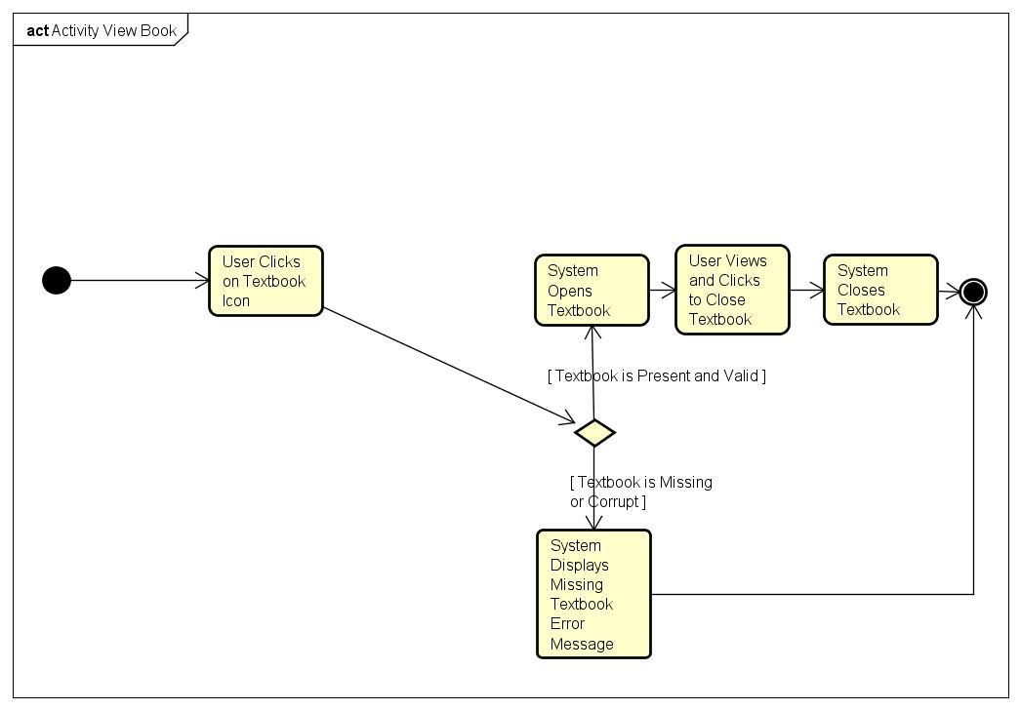

1. **Pre-Conditions**
   1. User must be logged onto the system and should not be doing the question that time. User should go to the resources bar and then should click “book” tool.
2. **Post-Conditions**
   1. The book is displayed.
3. **Failed End Condition**
   1. The book window doesn’t show up.
4. **Actors**
   1. User is able to view the Book.

**UC8 Flow of Events for the Display Question Use Case**

1. **Brief Description**
   1. The goal of this requirement is to display the question. It will be displayed when the User logs on to the system and starts an activity.

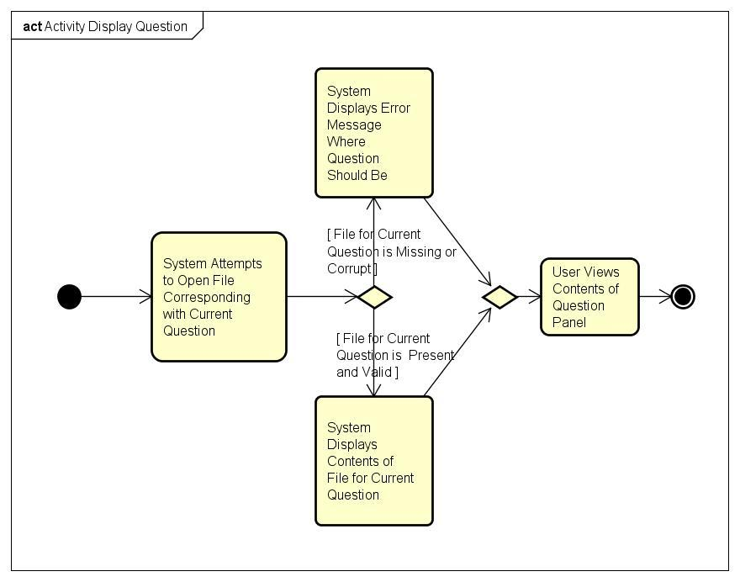

1. **Pre-Conditions**
   1. User must be logged onto the system .
2. **Post-Conditions**
   1. The question is displayed
3. **Failed End Condition**
   1. The display question window does not pop up.
4. **Actors**
   1. System displays the Question.

**UC9 Flow of Events for the Display Message Use Case**

1. **Brief Description**
   1. The goal of this requirement is to display a message. A message box will pop up if the user enters some wrong character in the text field.

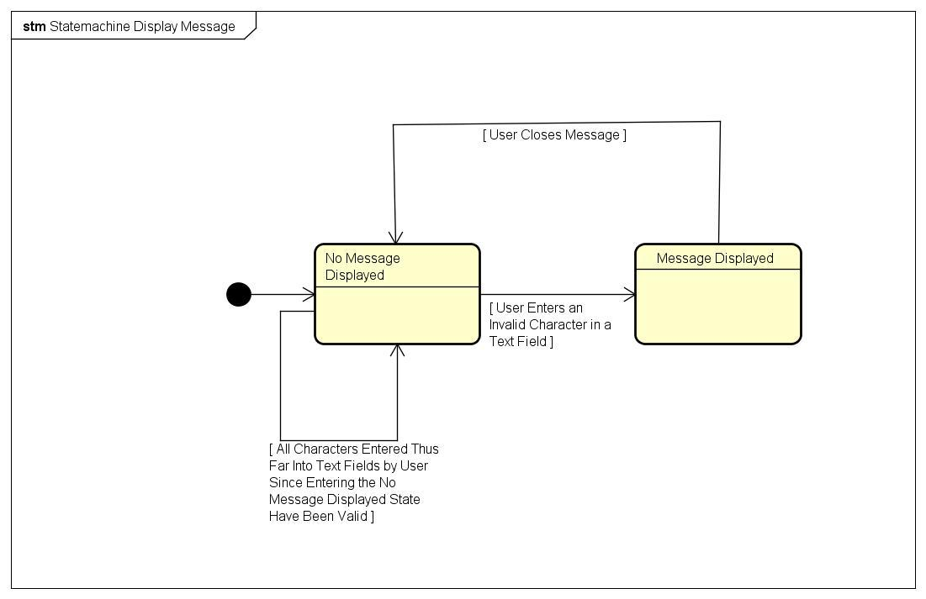

1. **Pre-Conditions**
   1. User must be logged onto the system. User has to enter some wrong character in the text field.
2. **Post-Conditions**
   1. Message box pops up.
3. **Failed End Condition**
   1. None
4. **Actors**
   1. System displays the Message.

**UC10 Flow of Events for the View Hint Use Case**

1. **Brief Description**
   1. The goal of this requirement is for the user to be able to click on the view hint button and the hint will pop-up. The hint will contain an example of a problem solved that is similar to the one that the user is working on. It will give a detailed explanation of the problem or concept.

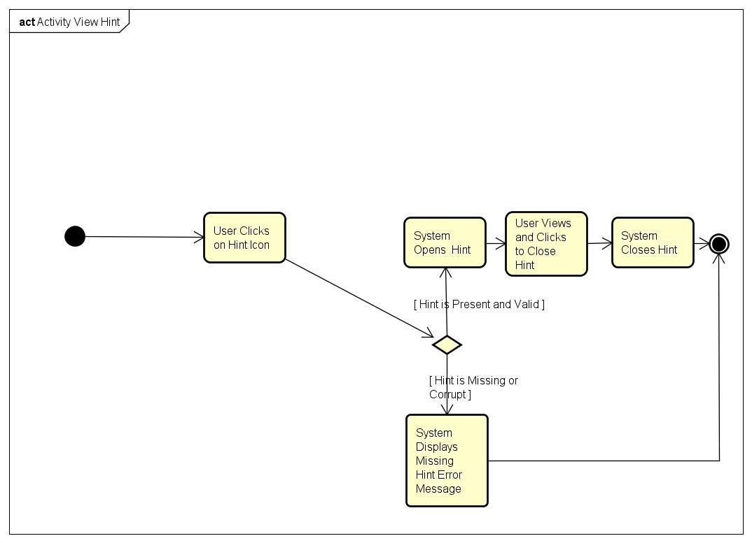

1. **Pre-Conditions**
   1. Logged in. Taking quiz.
2. **Post-Conditions**
   1. The User is able to see the pop up window with the hint.
3. **Failed End Condition**
   1. The window does not pop up.
4. **Actors**
   1. User.

**UC11 Flow of Events for the Display Timer Use Case**

1. **Brief Description**
   1. The goal of this requirement is for the system to display the a timer. The timer is meant to keep track and to show how much time is left in the quiz, or assignment. It will help the user to decide if they need to pick up the pace or if the are doing okay in time on the quiz, or assignment.

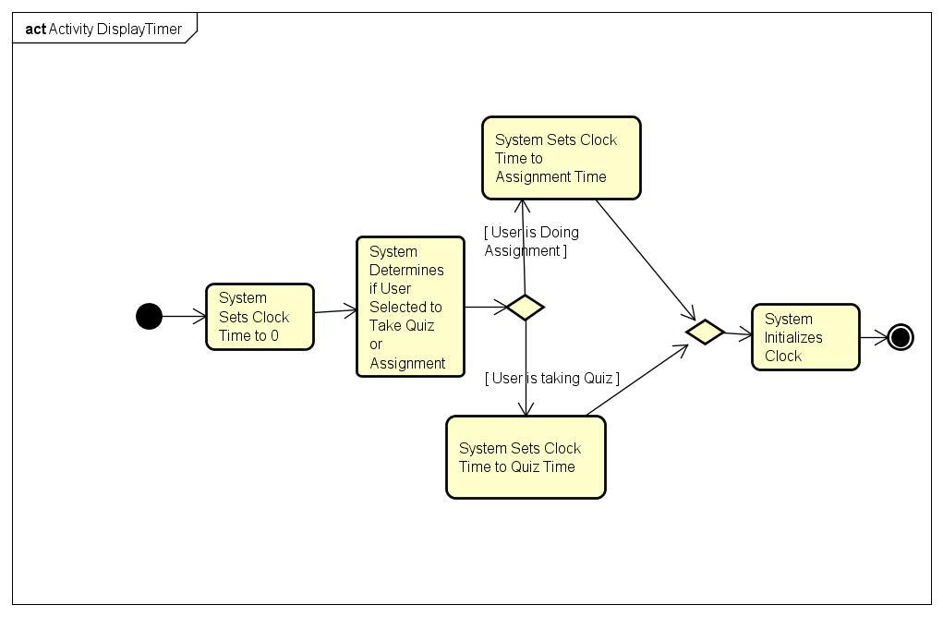

1. **Pre-Conditions**
   1. Logged in. Taking quiz. Taking Assignment.
2. **Post-Conditions**
   1. The time is displayed on the screen.
3. **Failed End Condition**
   1. The clock stops. It is not being displayed for the user to see. The clock is displaying the wrong time. The clock is moving either too slow or too fast.
4. **Actors**
   1. User.

**UC12 Flow of Events for the View Answer Use Case**

1. **Brief Description**
   1. The goal of this requirement is for the user to be able to click on the view answer button and the answer will pop-up. The user will be able to see what problems he got wrong on the quiz, assignment. The window will pop up with the quiz questions their answers and the correct answers.

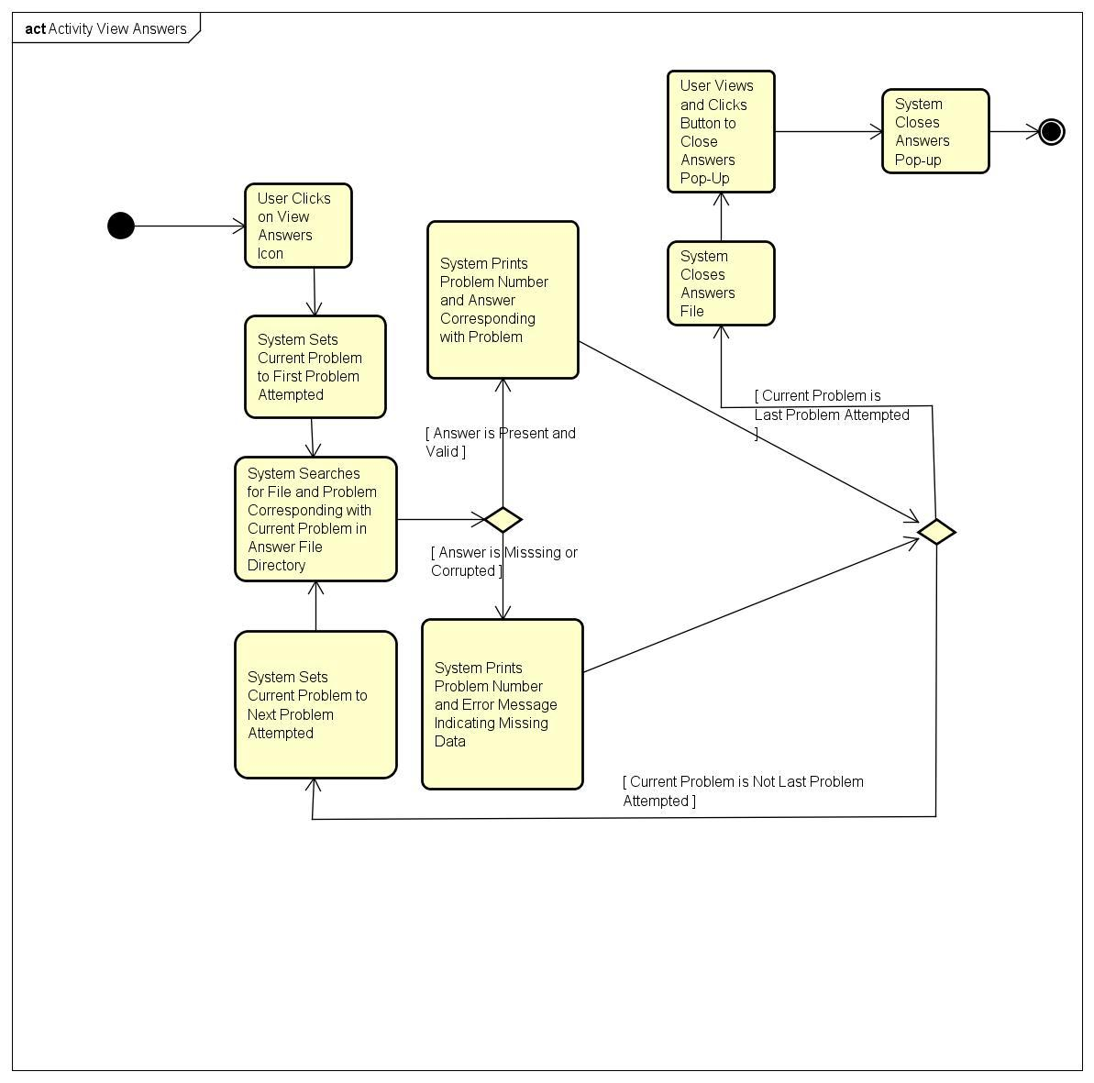

1. **Pre-Conditions**
   1. Logged in. Finished Taking quiz. Finished Taking Assignment.
2. **Post-Conditions**
   1. The User is able to see the pop up window with the answers to the quiz.
3. **Failed End Condition**
   1. The window does not pop up.
4. **Actors**
   1. User is able to view the answer.

**UC13 Flow of Events for the View solution Use Case**

1. **Brief Description**
   1. The goal of this requirement is for the user to be able to click on the view solution button and the solution will pop-up. The pop up window will display a similar problem and all the steps that are needed to solve that problem. It may sometimes include key concepts for the problem.

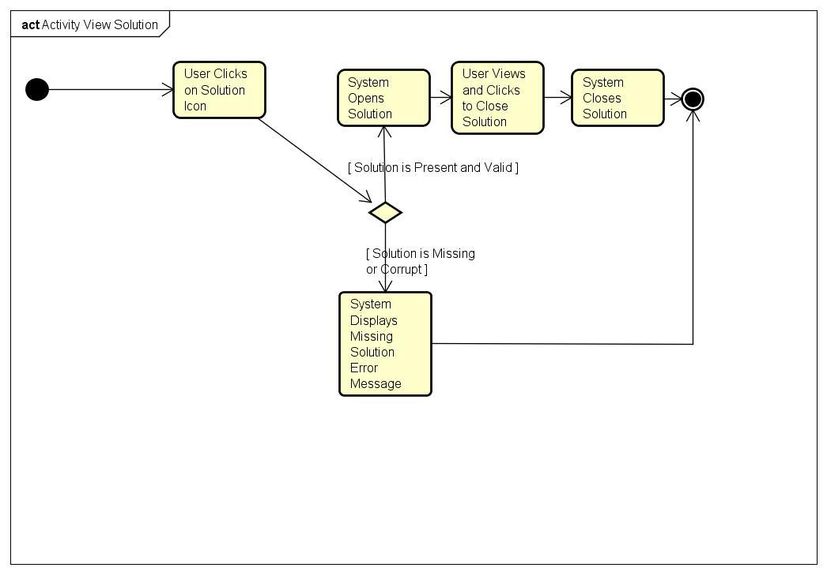

1. **Pre-Conditions**
   1. Logged in. Taking Assignment.
2. **Post-Conditions**
   1. The User is able to see the pop up window with the solution.
3. **Failed End Condition**
   1. The window does not pop up.
4. **Actors**
   1. User is able to view the answer.

**UC14 Flow of Events for the View Score Use Case**

1. **Brief Description**
   1. The goal of this requirement is for the user to be able to view to score that they scored in their quiz or assignment. The score will represent the number of correct answer, and the number of questions.

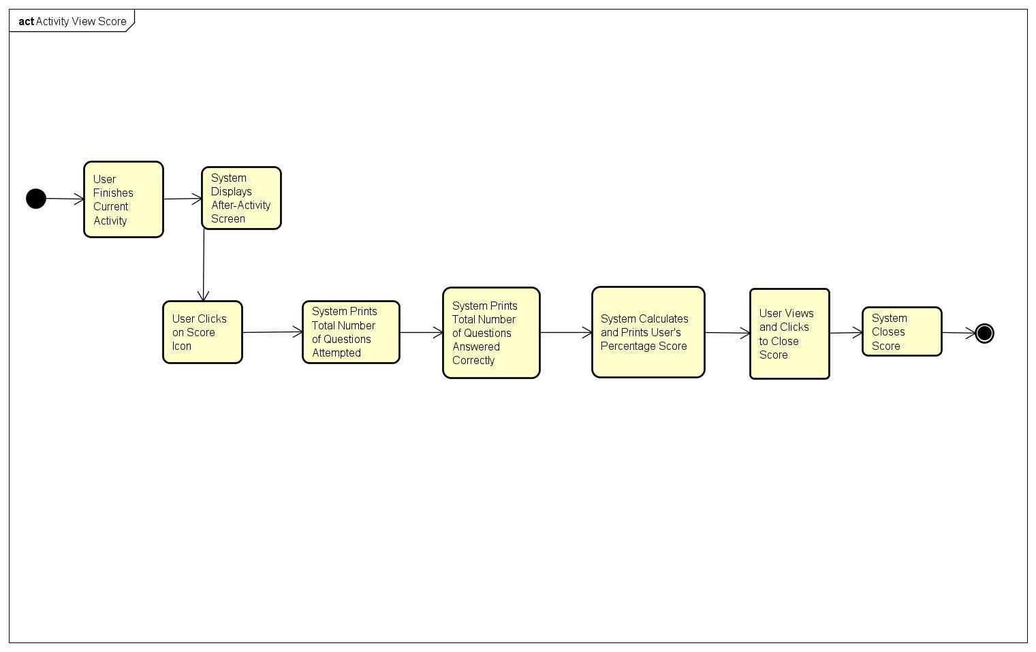

1. **Pre-Conditions**
   1. Logged in. Finished taking quiz, Finished taking assignment.
2. **Post-Conditions**
   1. The User is able to see the pop up window with the score.
3. **Failed End Condition**
   1. The window does not pop up.
4. **Actors**
   1. User is able to view the score.

**UC15 Flow of Events for the View Lesson Use Case**

1. **Brief Description**
   1. The goal of this requirement is to display the lesson of the question. It will be displayed when the User wants to see the lesson from where the question came from.

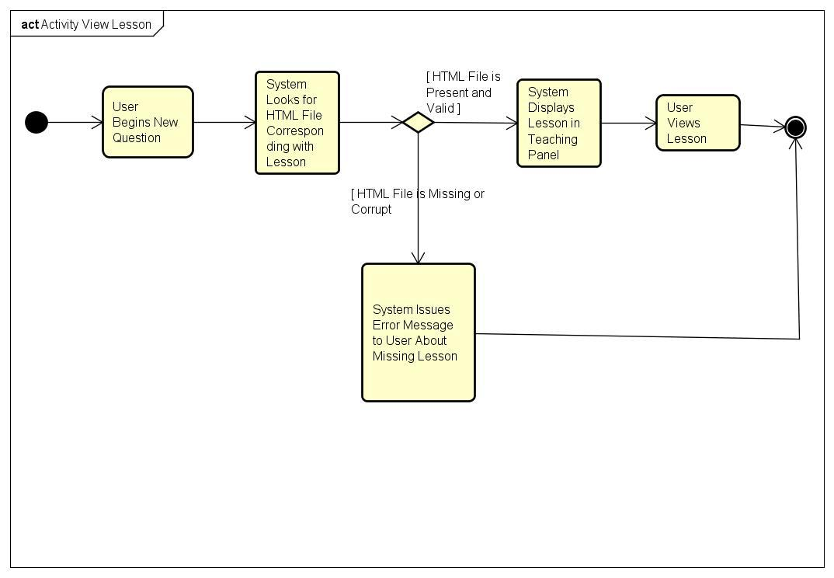

1. **Pre-Conditions**
   1. User must be logged onto the system and should be working on the question.
2. **Post-Conditions**
   1. Lesson of the question is  
      displayed.
3. **Failed End Condition**
   1. The lesson doesn’t pop up or wrong lesson is displayed.
4. **Actors**
   1. User is able to view the Lesson.

**UC16 Flow of Events for the View Video Use Case**

1. **Brief Description**
   1. The goal of this requirement is to display a video related to the question. It will be displayed when the User wants to see a video of that question.

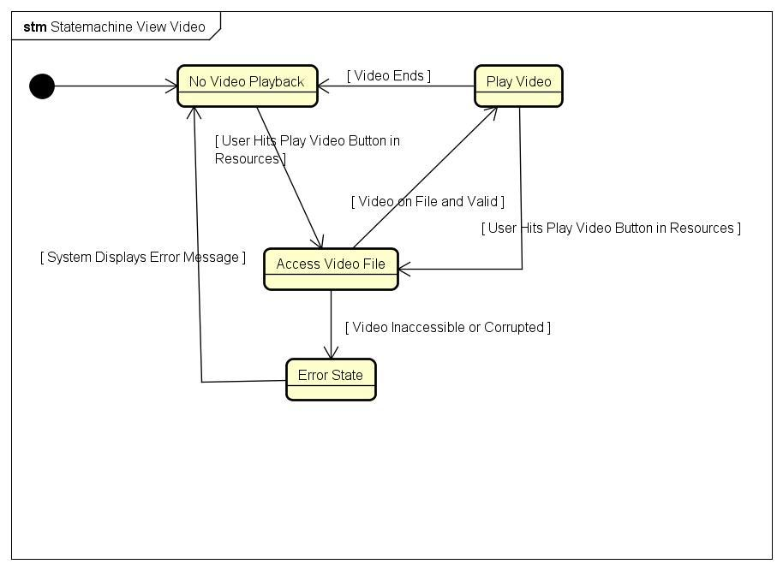

1. **Pre-Conditions**
   1. User must be logged onto the system and should be working on the question.
2. **Post-Conditions**
   1. Video of the question is  
      displayed.
3. **Failed End Condition**
   1. Video doesn’t pop up.
4. **Actors**
   1. User is able to view the Video.

**UC17 Flow of Events for Play Audio**

1. **Brief Description**
   1. After the user presses the button to play audio for a lesson, the system plays the corresponding audio for the lesson.

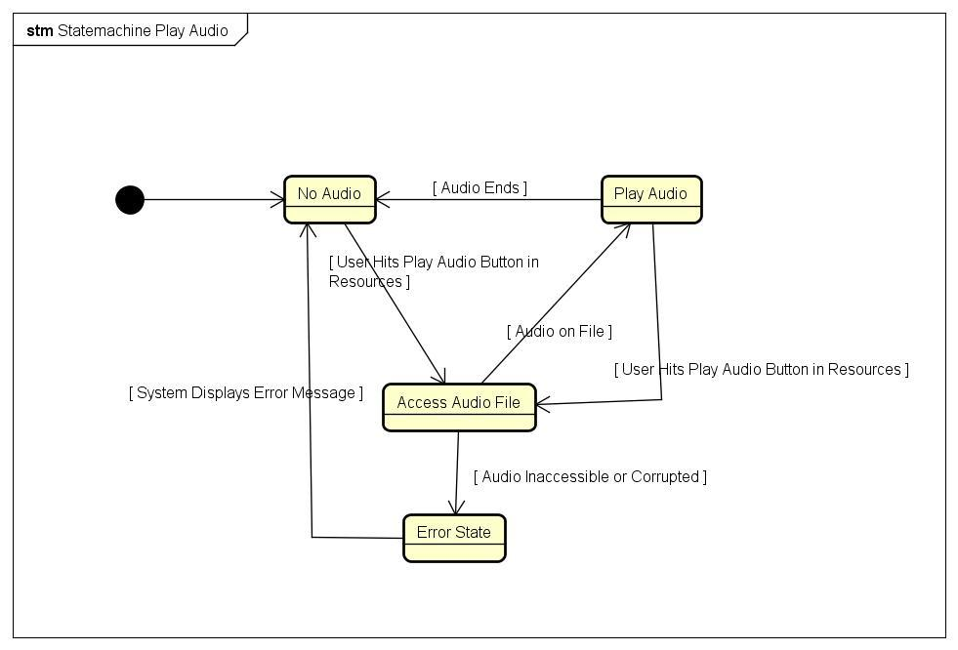

**b. Pre-Conditions**

i. User has logged in

ii. User is viewing a lesson

**d. Post-Conditions**

i. System has played the correct audio for the lesson, all the way through

**e. Failed End Condition**

i. The audio does not play

ii. The audio does not play correctly (it ends early or starts late)

iii. The audio is corrupted

**f. Actor(s)**

i. System

**UC18 Flow of Events for the Input Answer Use Case**

1. **Brief Description**
   1. This is the area where the user will be inputting the answer.

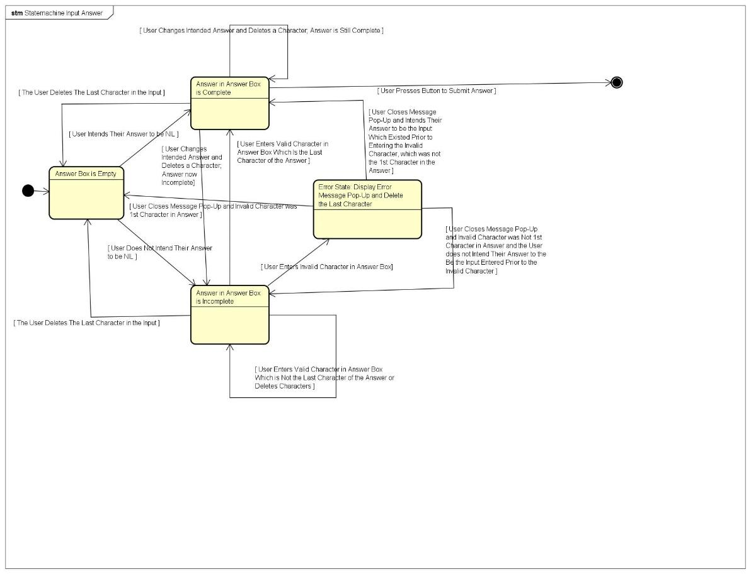

1. **Pre-Conditions**
   1. User must be logged onto the system and should be working on the question.
2. **Post-Conditions**
   1. User must enter only the  
      characters that are acceptable by the system. The number of characters should  
      not exceed the limit.
3. **Failed End Condition**
   1. User puts an unacceptable character or the number of character’s limit is crossed.
4. **Actors**
   1. User is able to input the Answer.

**UC19 Animate Avatars**

1. **Brief Description**
   1. The system will move the avatars based on the emotion of the face.



1. **Pre-Conditions**
   1. User must be logged into the system.
2. **Post-Conditions**
   1. The avatars should be moving and interactive if this use case is successful
3. **Failed End Condition**
   1. Avatar will be frozen and not move
4. **Actors**
   1. System

**UC20 Flow of Events for the Delete Profile Use Case**

1. **Brief Description**
   1. The goal of this requirement is to delete a profile. Its mainly used if the user wants to delete the profile and create a new one .

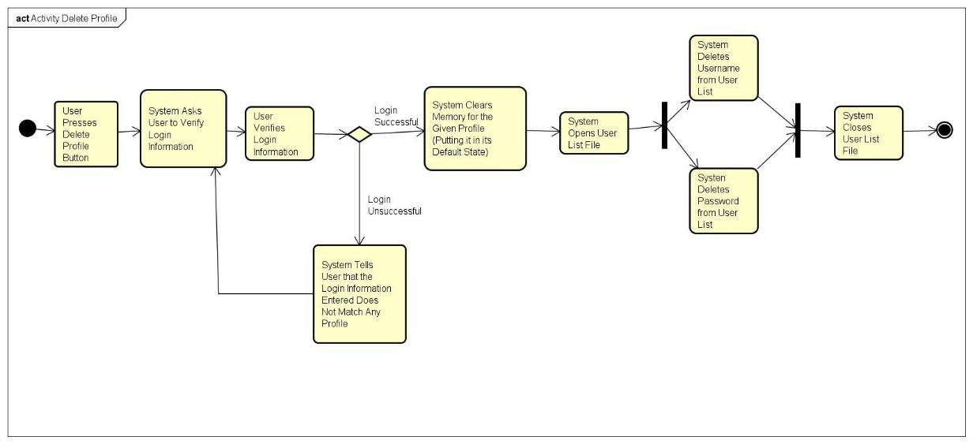

1. **Pre-Conditions**
   1. The user should already have a profile.
   2. The user should be logged in.
2. **Post-Conditions**
   1. The profile of the user will be deleted.
3. **Failed End Condition**
   1. The profile still exists after deleting.
4. **Actors**
   1. User deletes the profile.

**UC21 Flow of Events for the Display Tasks Use Case**

1. **Brief Description**
   1. The goal of this requirement is to display the number of tasks that is in the system. The user can view this in the menu and could see how many tasks has been completed or how many are left.

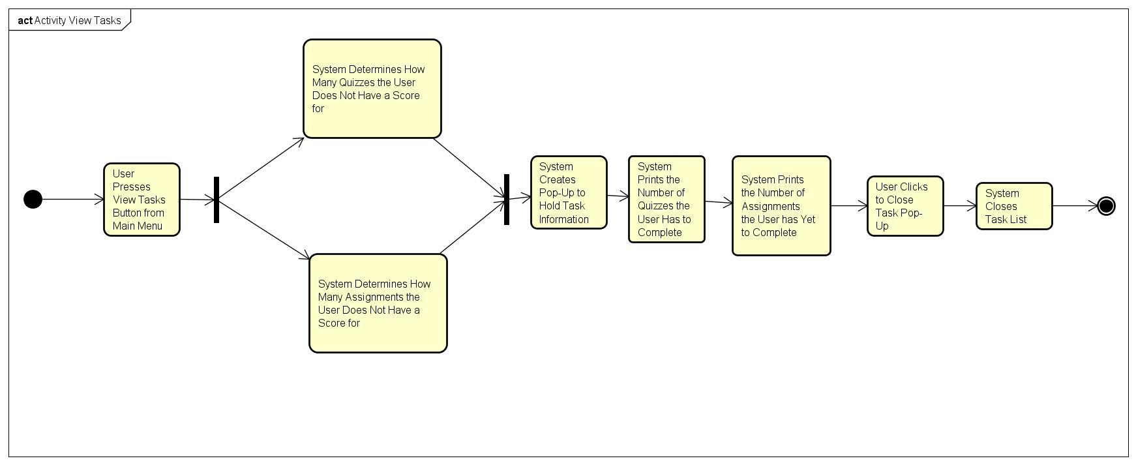

1. **Pre-Conditions**
   1. The user should be logged in.
2. **Post-Conditions**
   1. The number of task will be displayed.
3. **Failed End Condition**
   1. The number of tasks that are displayed is incorrect.
4. **Actors**
   1. System displays the tasks.

**UC22 Flow of Events for Maintain Student Information**

1. **Brief Description**
   1. The system must preserve the profile and old scores for a student. It should also maintain a database of topics to suggest the student work on.

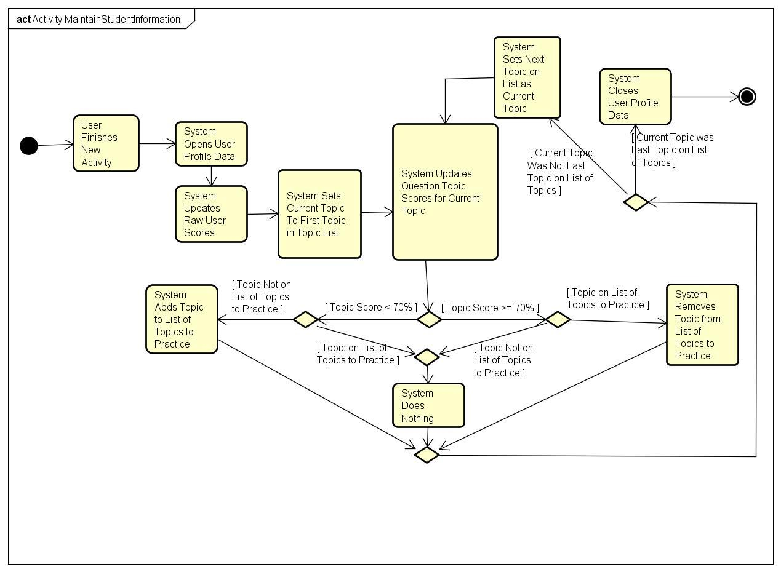

**b. Pre-Conditions**

1. Student must have an existing profile

**c. Post-Conditions**

1. Student information will be correct and up to date

**d. Failed End Condition**

1. Student information is missing
2. Student information is corrupted

**e. Actor(s)**

i. System

**UC23 Flow of Events for View Profile**

1. **Brief Description**
   1. After the user has prompted the system to display their profile, the system searches for and displays their profile within the frame of the tutoring system.

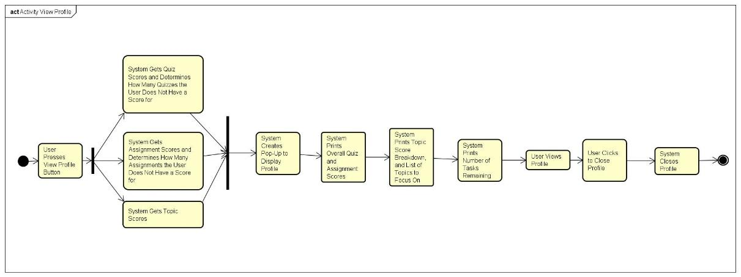

1. **Pre-Conditions**
   1. User has a profile
   2. User has prompted the system to view profile
2. **Post-Conditions**
   1. The user’s profile is displayed on the screen
3. **Failed End Condition**
   1. Nothing is shown on the screen
   2. A partial profile is shown on the screen
4. **Actor(s)**
   1. System and User

**UC24 Flow of Events for Create Profile**

1. **Brief Description**
   1. Upon attempting to open the Tutoring System’s frame, the user is prompted to log on or create a profile if they do not have a profile. If the latter is the case, the system will create a profile with parameters depending on user inputs.

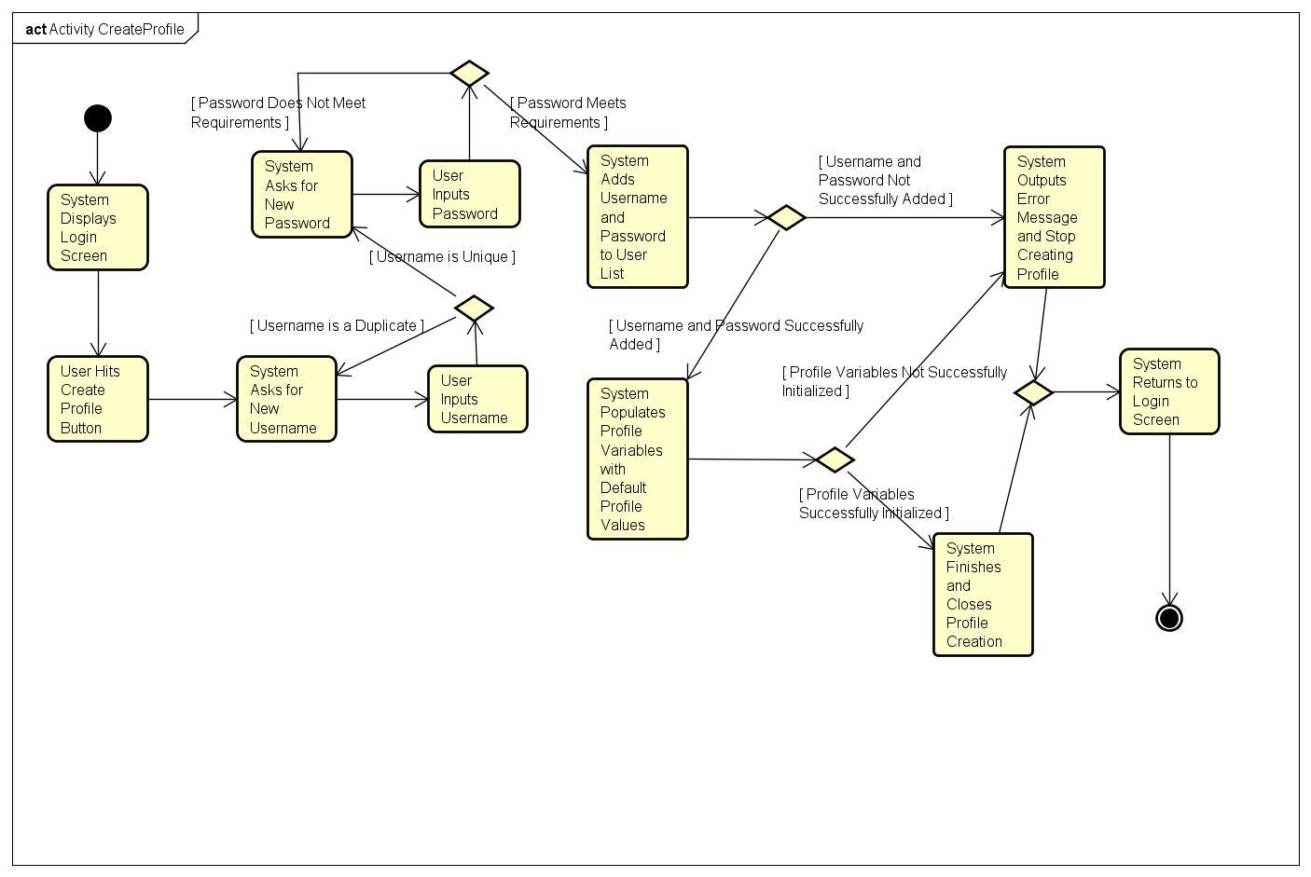

1. **Pre-Conditions**
   1. User is attempting to authenticate their identity
   2. User does not have a profile
2. **Post-Conditions**
   1. User has a profile on file
3. **Failed End Condition:**
   1. No profile created
   2. The profile was created as a duplicate of another profile
4. **Actor(s)**
   1. System and User

**UC25 Flow of Events for Log In**

1. **Brief Description**
   1. The user, if not already logged in, musty be able to enter their login information into the system when prompted, to authenticate their identity.

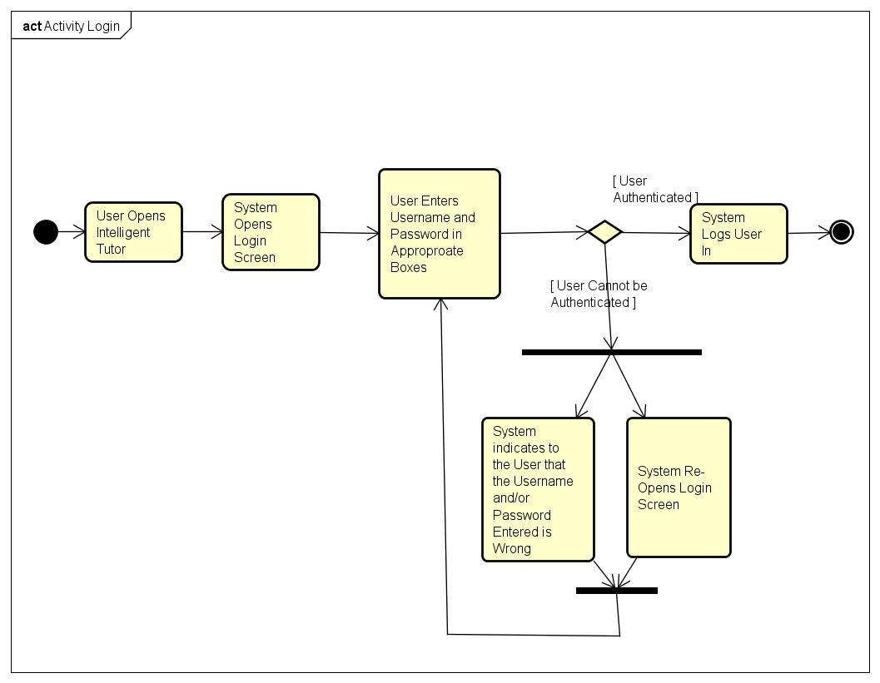

1. **Pre-Conditions**
   1. User has a profile
   2. User is attempting to open the tutoring system
   3. User is not logged in
2. **Post-Condition**
   1. User is logged in
3. **Failed End Condition**
   1. User is not logged on
4. **Actor(s)**
   1. User and System

**UC26 Flow of Events for User Authentication**

1. **Brief Description**
   1. When the user opens the program, and attempts to log in, the system should authenticate the user’s identity.

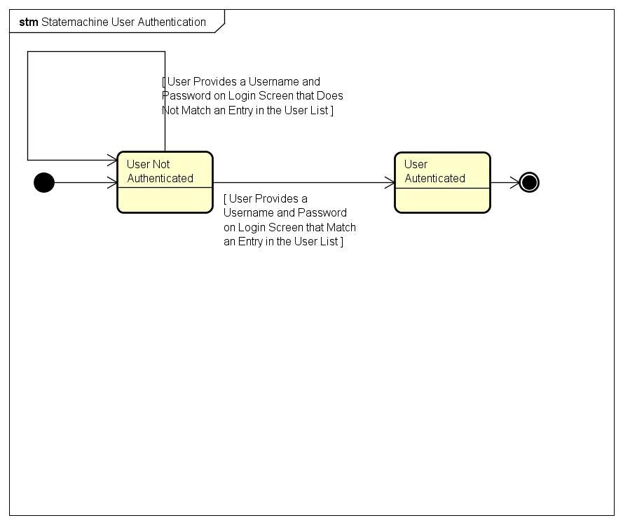

1. **Pre-Conditions:**
   1. User has a profile,
   2. User is attempting to log into tutoring system
   3. User has not been authenticated yet
2. **Post-Condition:**
   1. User is authenticated and can access their profile
3. **Failed End Condition:**
   1. User is not authenticated
4. **Actor:**
   1. User and System

**UC27 Use Calculator**

1. **Brief Description**
   1. The system will have a built in calculator that will provide answers in case the student does not have a calculator of their own.

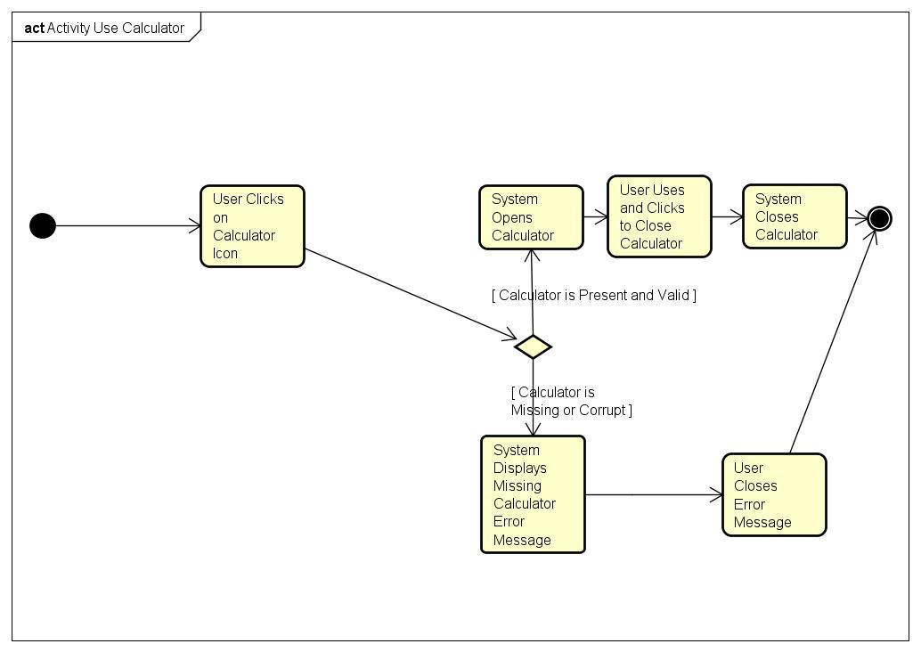

1. **Pre-Conditions**
   1. The user must be logged into the system and must be in the midst of a quiz or assignment.
2. **Post-Conditions**
   1. The quiz or assignment must be finished.
3. **Failed End Condition**
   1. The calculator gives wrong results.
4. **Actors**
   1. User

**UC28 Flow of Events for Remember Me**

1. **Brief Description:**
   1. When the user logs in, there should be the option for the user to save their login information, so that, next time that the user needs to be authenticated, they do not need to enter login information again.

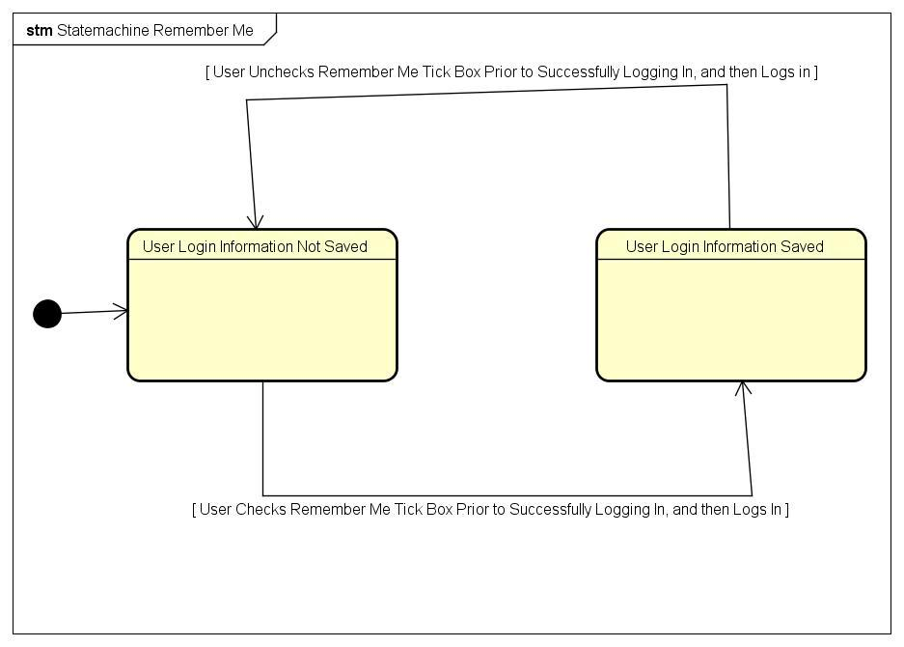

1. **Pre-Conditions:**
   1. User has a profile
   2. User is not currently authenticated.
2. **Post- Condition:**
   1. User has been authenticated.
3. **Failed End Condition:**
   1. User cannot be authenticated
4. **Actor:**
   1. System and User

**UC29 Flow of Events for Display Menu**

1. **Brief Description:**
   1. After the user is authenticated, the menu should be displayed on the screen, and should have the corresponding JFrames for its default state

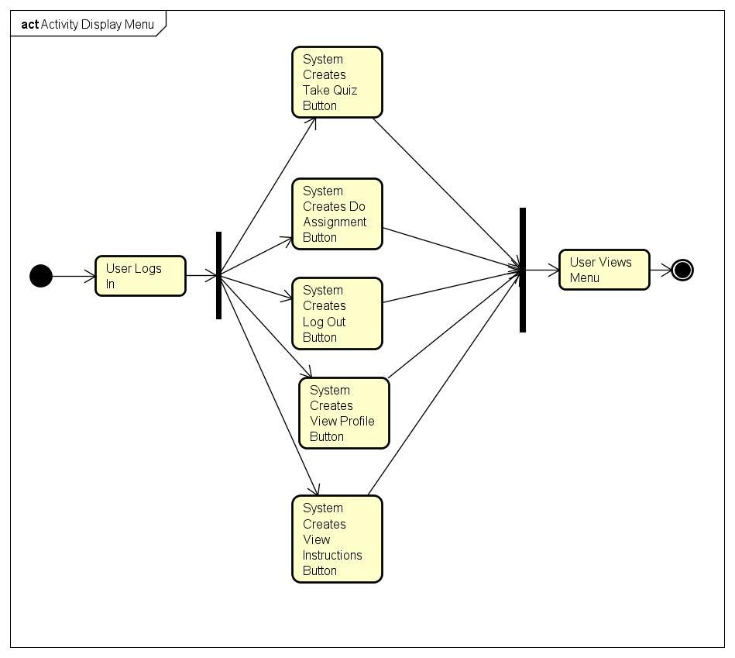

1. **Pre-Conditions:**
   1. System has been booted
   2. The user has been authenticated
2. **Post-Conditions:**
   1. Universe JFrame of the tutoring system is correctly displayed on the screen,
3. **Failed End Condition:**
   1. Nothing is displayed.
4. **Actor(s):**
   1. System

**UC30 Flow of Events for View Instructions**

1. **Brief Description:**
   1. When the user has opened the menu, they have the option of viewing instructions for the entire program. The instructions go over what the various menu options the user may take

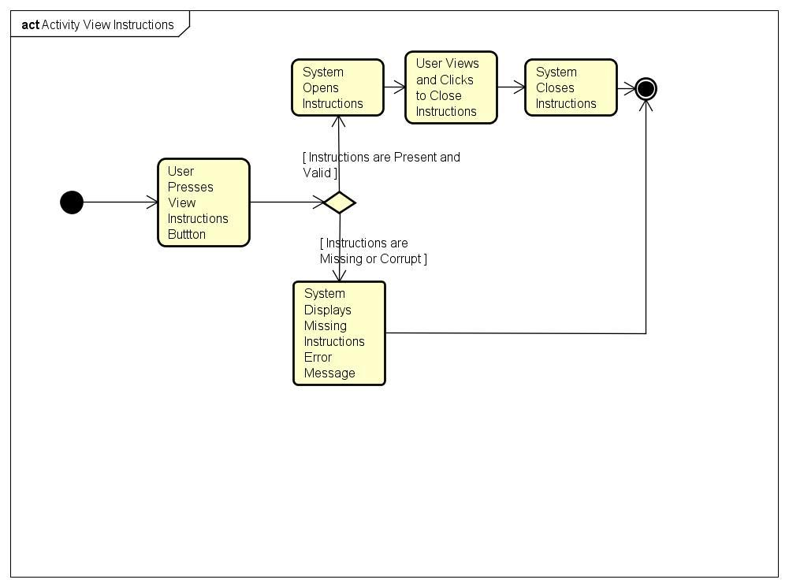

1. **Pre-Conditions:**
   1. System has been booted
   2. User has been authenticated
2. **Post-Conditions:**
   1. Instructions for general use of the program have been displayed
3. **Failed End Condition:**
   1. The instructions do not appear.
   2. The instructions are corrupted
4. **Actor(s):**
   1. System and User

**UC31 Flow of Events for View Notes**

1. **Brief Description:**
   1. The user should be able to pull up a custom note sheet from within the program, in order to take notes when using the various resources within the program.

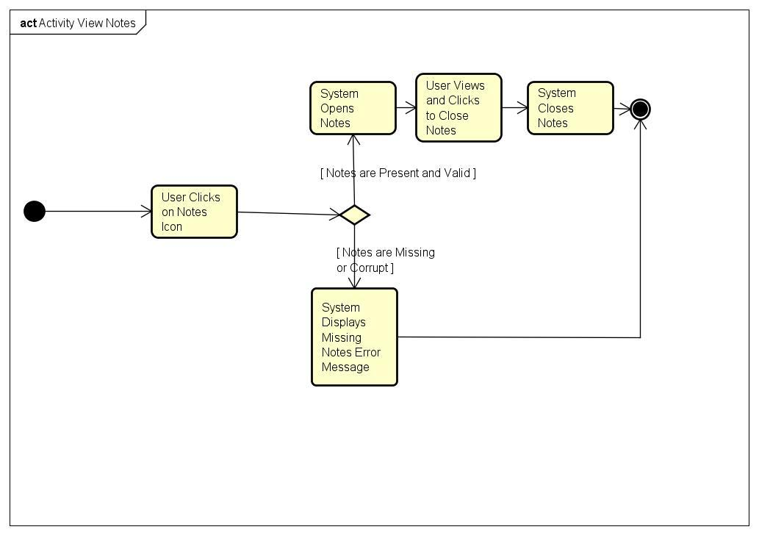

1. **Pre-Conditions:**
   1. User has been authenticated
   2. User is answering a question
2. **Post-Conditions:**
   1. Note sheet has been pulled up within the program
3. **Failed End Condition:**
   1. The note sheet does not appear
   2. The note sheet is corrupted
4. **Actor(s):**
   1. User

**UC32 Flow of Events for Set Difficulty Level**

1. **Brief Description:**
   1. The user should be able to set the difficulty level anywhere from Level 1-5 from the menu, prior to answering questions.

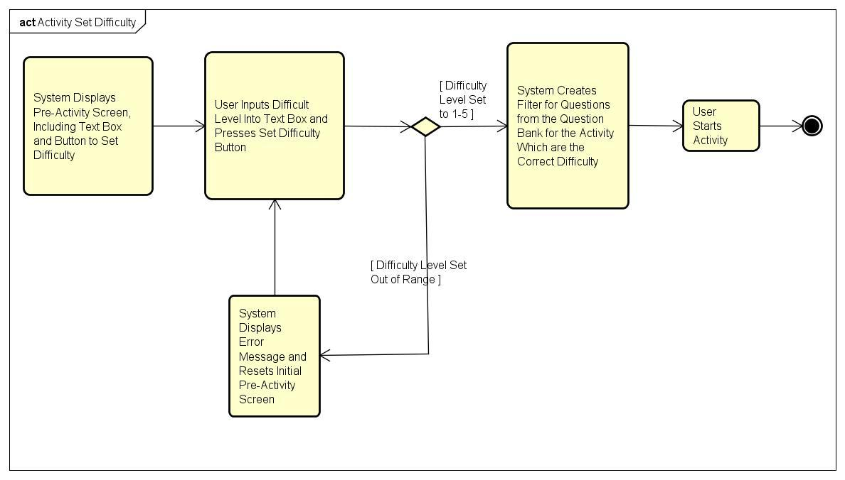

1. **Pre-Conditions:**
   1. System has been booted
   2. The user has been authenticated
2. **Post-Conditions:**
   1. Difficulty is set to the user’s desired level
3. **Failed End Condition:**
   1. The difficulty is set to a level outside of the program’s difficulty range
4. **Actor(s):**
   1. User and System

**UC33 Tell User Which Topics to Focus On**

1. **Brief Description**
   1. After the user has been evaluated by the system based on his/her performance, the system will find the topics that the user needs more practice and to pay more attention on.

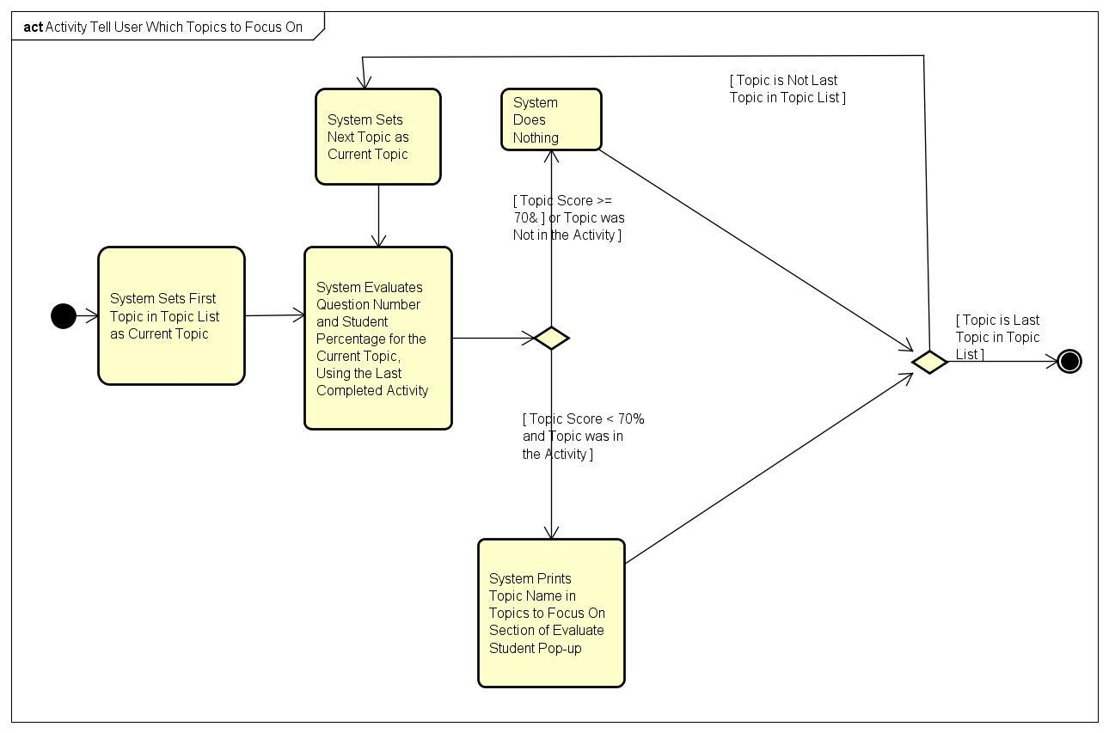

1. **Pre-Conditions**
   1. A quiz or assignment would have to be evaluated.
   2. Student must have topics that he/she is struggling with or needs more practice
2. **Post-Conditions**
   1. The student will have suggested topics to work on in order to improve understanding on the subject.
3. **Failed End Condition**
   1. The user has mastered all topics.
4. **Actors**
   1. System

**34: Award Medals**

1. **Brief Description**
   1. If the student’s performance is adequate, he/she shall receive a medal as an incentive.

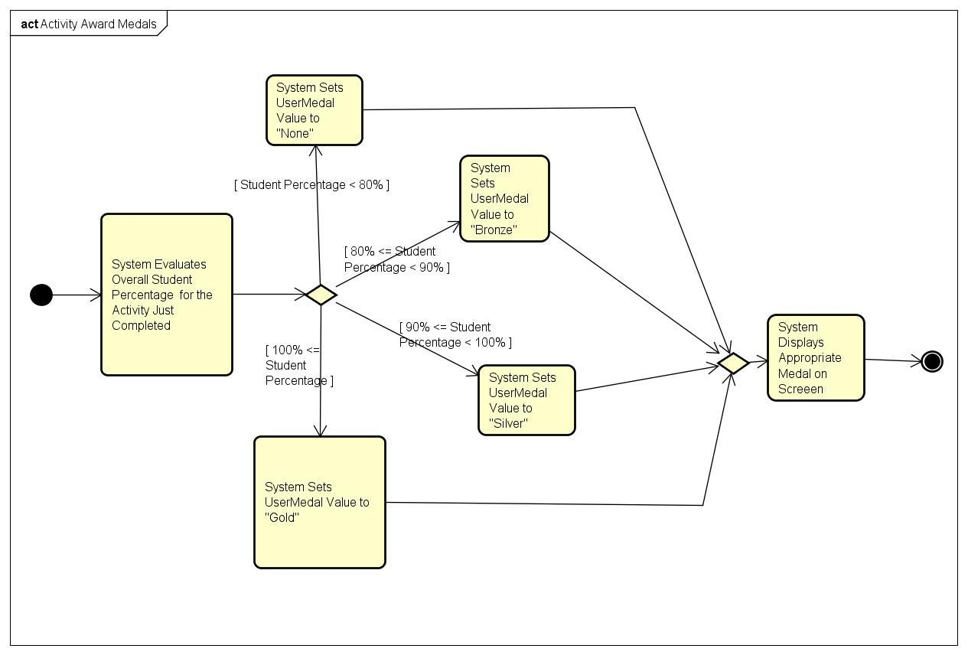

1. **Pre-Conditions**
   1. User must be taking a quiz or assignment
   2. User must score high enough to meet medal criteria
2. **Post-Conditions**
   1. None
3. **Failed End Condition**
   1. Student will not receive a medal
4. **Actors**
   1. System

**35: Display Keyboard Map**

1. **Brief Description**
   1. The keyboard with usable characters, formulas, and equations will be displayed.

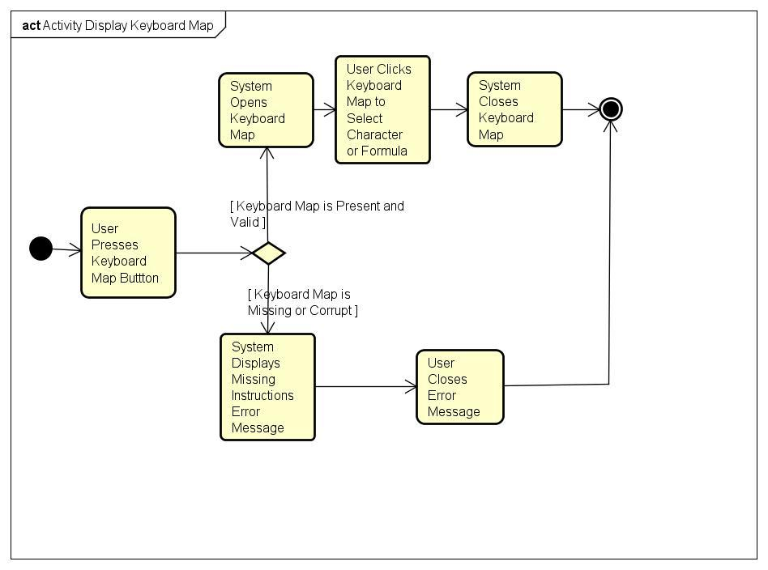

1. **Pre-Conditions**
   1. User must be taking quiz or assignment
2. **Post-Conditions**
   1. A character, formula, or equation will be selected and keyboard will disappear
3. **Failed End Condition**
   1. There will not be a keyboard map displayed.
4. **Actors**
   1. The system will display the possible characters for the user.

**36: View Quiz**

1. **Brief Description**
   1. The user will view the quiz from the assessor JPanel. A quiz will be timed and will not contain hints.

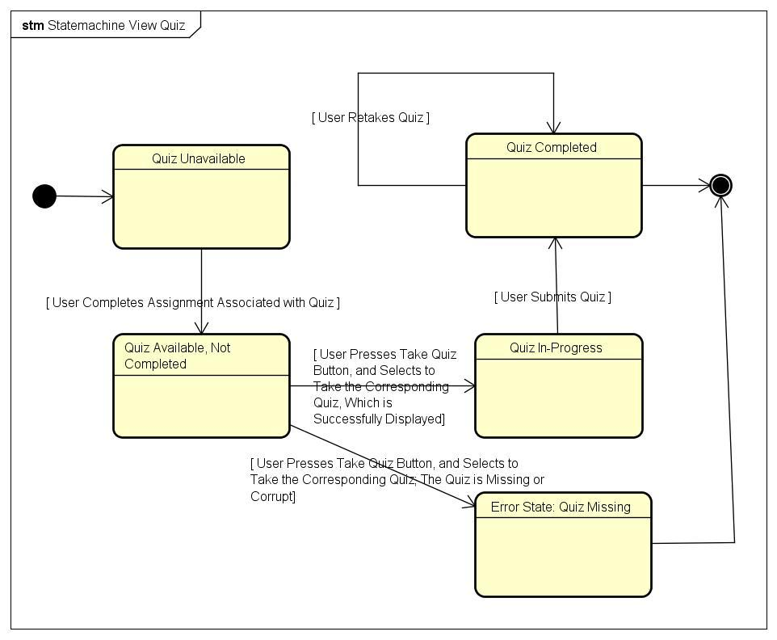

1. **Pre-Conditions**
   1. User must be logged in to the system and have completed lesson for the topic
2. **Post-Conditions**
   1. The user’s results will be evaluated.
3. **Failed End Condition**
   1. The quiz will not be displayed
   2. User will fail the quiz
4. **Actors**
   1. The user will have the quiz on display.

**37: Print Results**

1. **Brief Description**
   1. The results of the quiz or assignment will be printed by the system.

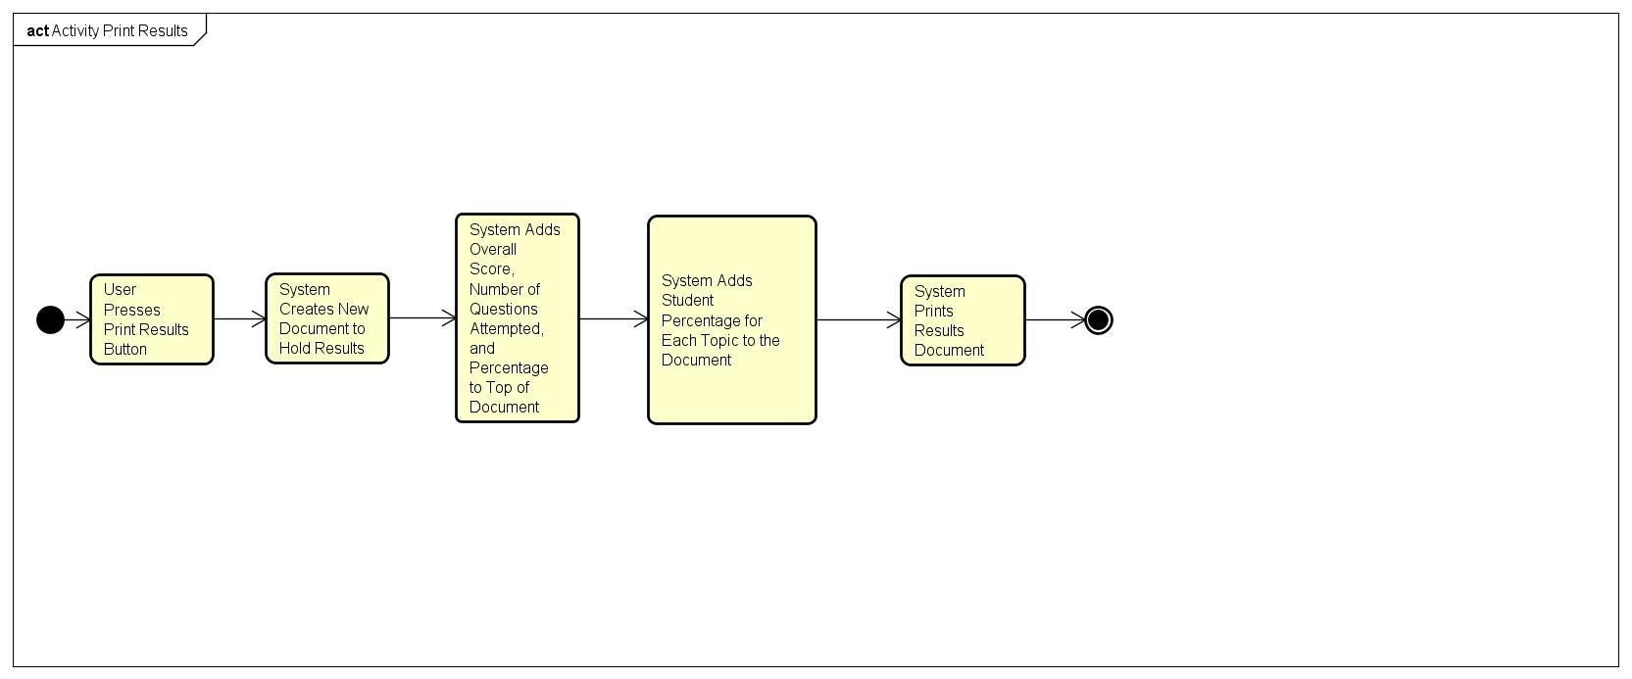

1. **Pre-Conditions**
   1. The assignment or quiz will have to be finished.
2. **Post-Conditions**
   1. The results and targeted topics will be shown to the user.
3. **Failed End Condition**
   1. No results will be displayed
   2. The quiz or assignment will have to be retaken.
4. **Actors**
   1. The system will have the results on display.

**38: View Assignment**

1. **Brief Description**
   1. The student will be able to take a look at the assignment that is assigned by the system.

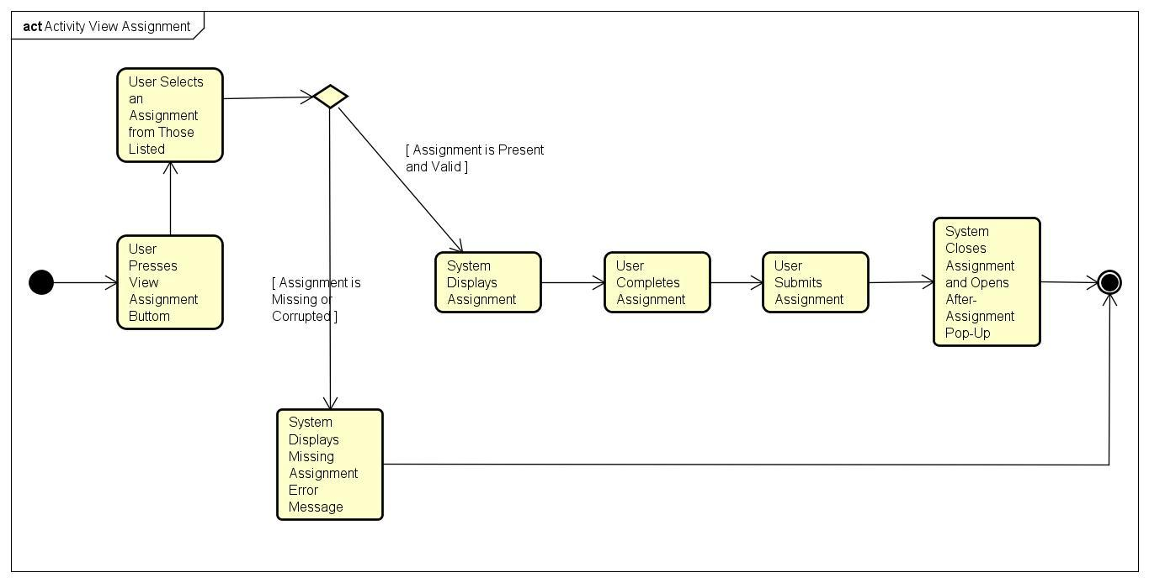

1. **Pre-Conditions**
   1. The user must be signed into the system
2. **Post-Conditions**
   1. The assignment will be on display in the system interface.
3. **Failed End Condition**
   1. There will be no assignment assigned.
4. **Actors**
   1. The user will have the assignment on display

**39: Log Out**

1. **Brief Description**
   1. User will be able to sign out of the system and their profile.

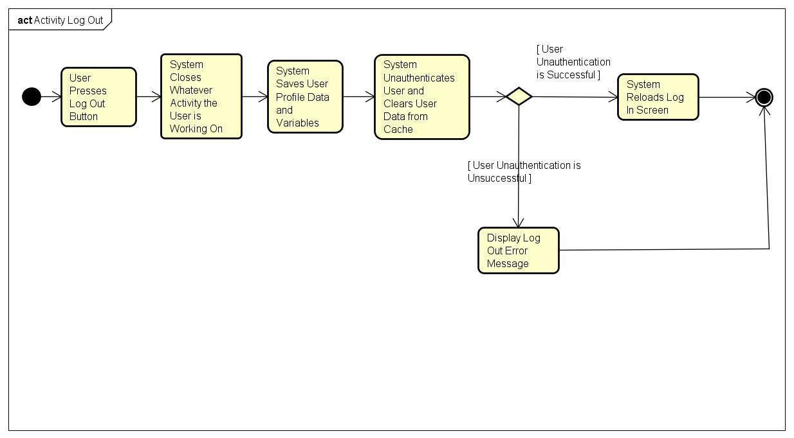

1. **Pre-Conditions**
   1. The user must be signed into the system.
2. **Post-Conditions**
   1. The system will not be logged into any account.
3. **Failed End Condition**
   1. The system will not sign the user out.
4. **Actors**
   1. The user will be signed out of the system.

**40: Evaluate Student**

1. **Brief Description**
   1. After the user has completed his/her quiz, there will be an evaluation based on the performance.

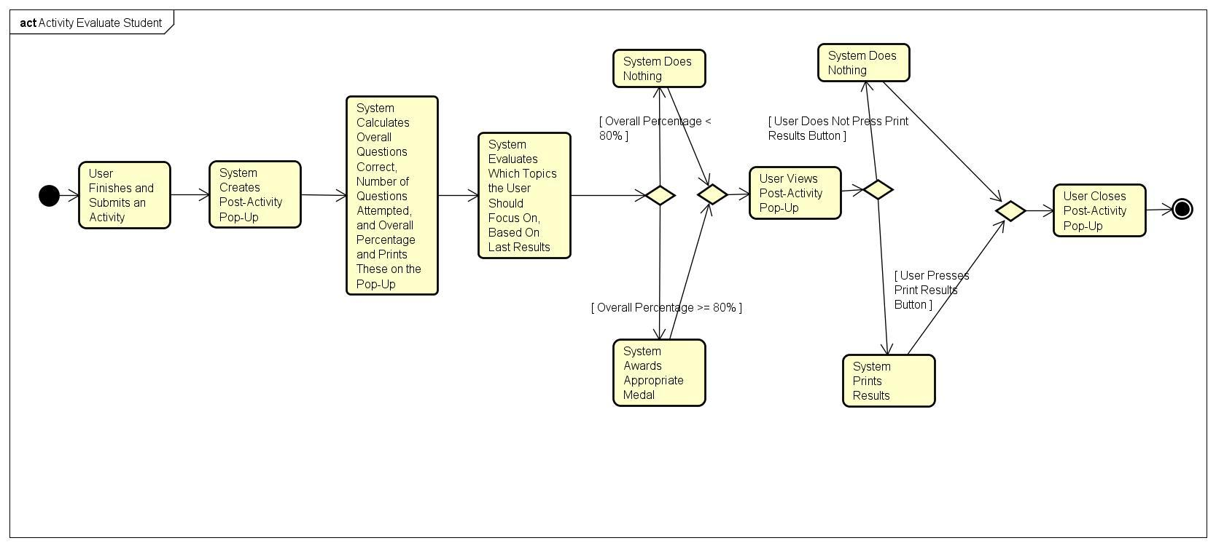

1. **Pre-Conditions**
   1. Must take quiz or complete assignment.
2. **Post-Conditions**
   1. Assign topics to focus on.
3. **Failed End Condition**
   1. User will not have any topics to review.
4. **Actors**
   1. The system will have evaluated the student’s performance

**VI. Non-Functional Requirements**

**NR1: Accessibility**

NR1.1 Any able adult should be able to easily use system

* The tutoring system should be intuitive enough for any adult to be able to figure out its use after using it for a limited time.

NR1.2 Software should be able to be used by disabled

* The tutoring software should have options for the blind and deaf to be able to use the tutoring system

**NR2: Usability**

NR2.1 All code development shall be done with Java

* The tutoring system should be written in Java

NR2.2 Can’t be mobile friendly

* The tutoring system will not be useable on mobile devices

NR2.3 Should be able to be used across all OS platforms

* The tutoring system should be useable on PC, Macintosh, and Linux distros

NR2.4 Network bandwidth should be adequate

* The bandwidth allocation for the program should be sufficient to manipulate web elements

NR2.5 Size of software must be under 5 gigabytes

* Total install size of the program should be less than 5 gigabytes

**NR3: Security**

NR3.1 Only the user should be able to access his/her information

* User data should only be accessible to its corresponding user

NR3.2 All data should be stored on servers

* Data should be stored on a server, as opposed to the user’s memory

**NR4: Performance**

NR4.1 Should be able to handle a good amount of users

* The system should be able to handle multiple users

NR4.2 The system will display images in real-time

* The system should be able to display real-time imagery

NR4.3 Page response time must be immediate

* There should be little to no delay in accessing the various features of the program

NR4.4 There must be no faults during runtime

* The program should be stable and not crash when running

**NR5: Quality**

NR5.1 3 Panels

* The program’s frame should contain 3 panels, each with different content

NR5.2 Slider must have four positions

* There should be a slider on the frame of the program, having 4 positions

NR5.3 Create an SRS document

* An SRS document should be generated to go with the program

NR5.4 All previous work should be able to be reused (code)

* Code used in designing the initial version of the program should be conserved

NR5.5 System will be maintained and repaired after launch

* The system should be changeable after launch; there should be the abilituy for users to troubleshoot

NR5.6 Avatar can not be copied from another source

* Avatars used must be original

NR5.7 Software must be free for all students and teachers

* This program is freeware.

**VII. Glossary**

Bandwidth: bit-rate of available information. Measures speed of software.

OS: Operating System